<https://linuxhint.com/arduino-nano-hc05-bluetooth-sensor/>

**Step 1:**Open the Bluetooth settings in your smartphone and search for the new devices. Click the HC-05 device.



**Step 2:**Pair the HC-05 sensor with a smartphone using the password 1234.

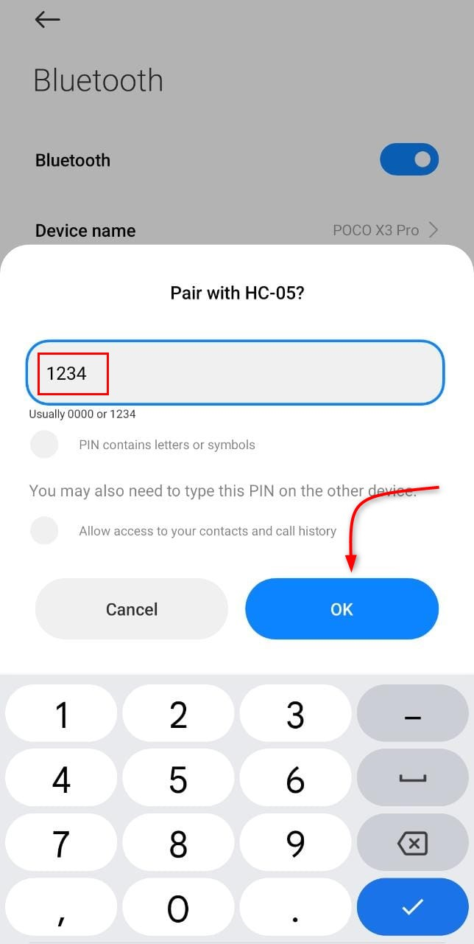

**Step 3:**Now open the App store on your smartphone and install the [Arduino Bluetooth Controller](https://play.google.com/store/apps/details?id=com.giumig.apps.bluetoothserialmonitor&hl=en&gl=US).

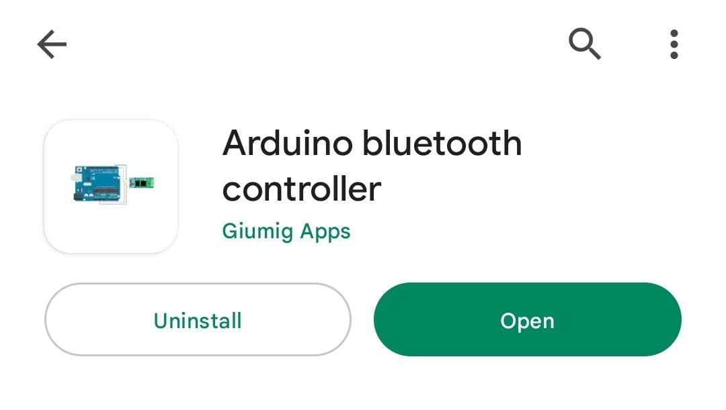

**Step 4:**Open the application and pair the HC-05 sensor.

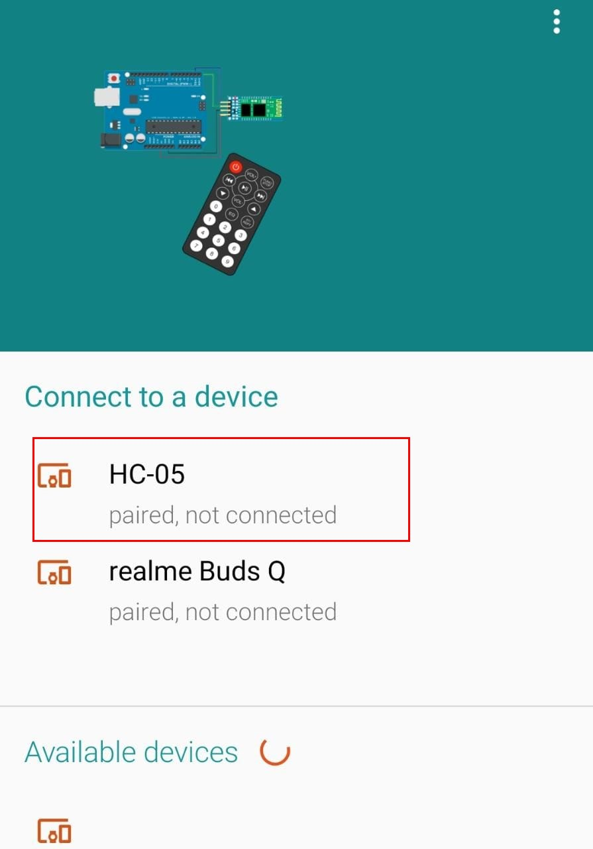

**Step 5:**Click the HC-05 Bluetooth and select the switch mode.

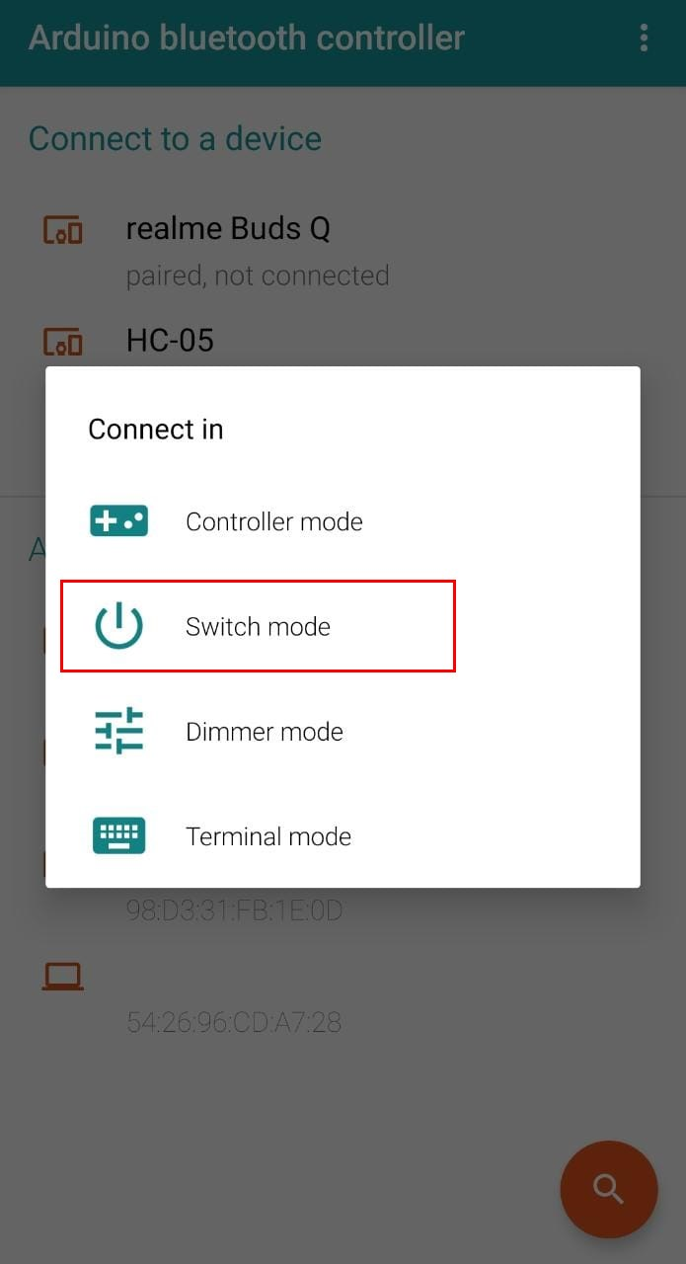

**Step 6:**Set the values for the switch button. 1 value corresponds to HIGH and 0 is equal to LOW.

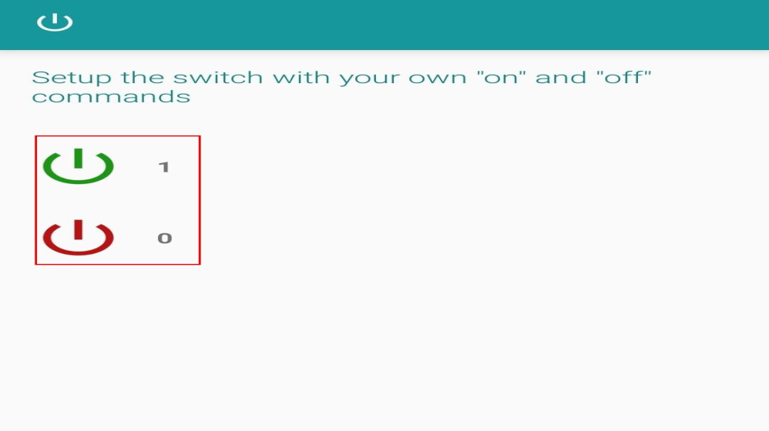

We have set up the Bluetooth application on our smartphones. Now we will control LEDs using the smartphone Bluetooth signal.

**Output**

Click the switch button and it will turn green.

